Lab-7
Batch Code : ANP-D3393
Name : Vignesh S
ID : AF05054428
Topic : SQL

Task 1: Update the Student table with the following information: Change the email to 'jane_Smith@example.com' Where FirstName is 'Jane' and LastName is 'Smith.

mysql> update student set email = 'jane_Smith@example.com' where first_name = 'Jane' and last_name = 'Smith'
-> ;
Query OK, 1 row affected (0.01 sec)
Rows matched: 1 Changed: 1 Warnings: 0
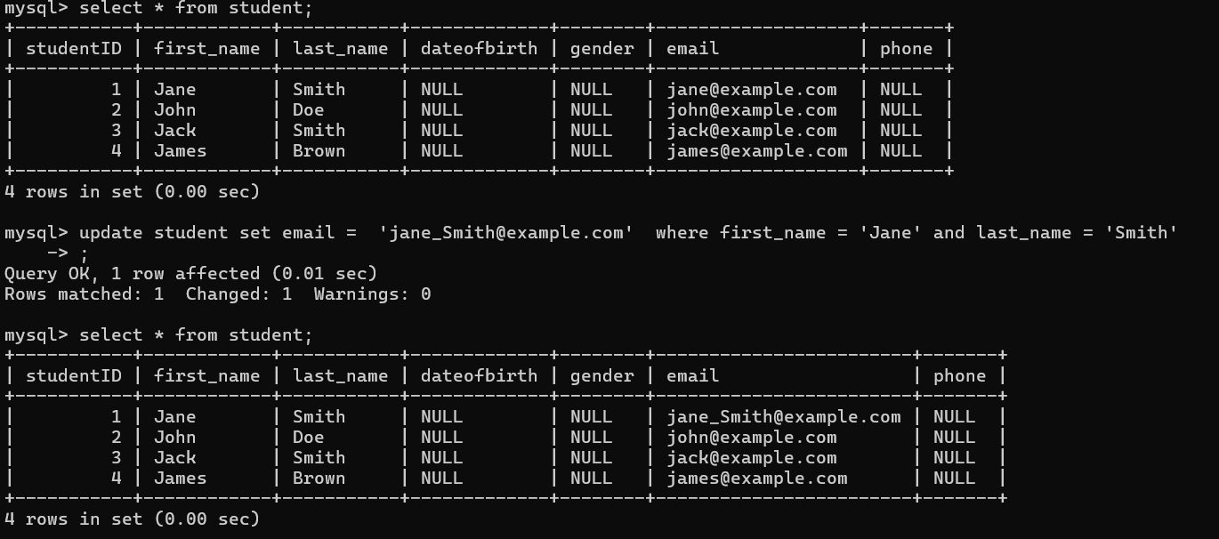

Update the Instructor with the following information: Change the email to 'rogerwhite@example.com' Where FirstName of the instructor is 'Roger' and LastName is 'White';
mysql> update instructor set email='rogerwhite@example.com' where firstname='Roger' and lastname='White';
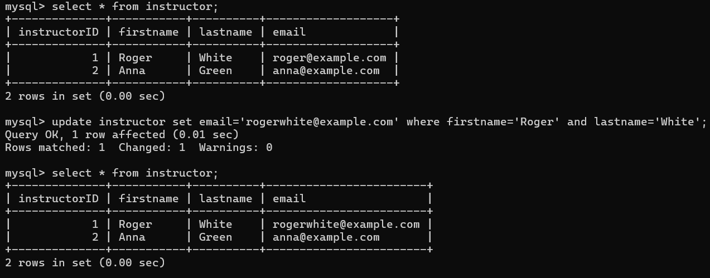
Delete record from the Student table on following condition: Delete student/students records from the Student table where last name is Smith.
mysql> delete from student where last_name='Smith';
Query OK, 2 rows affected (0.04 sec)
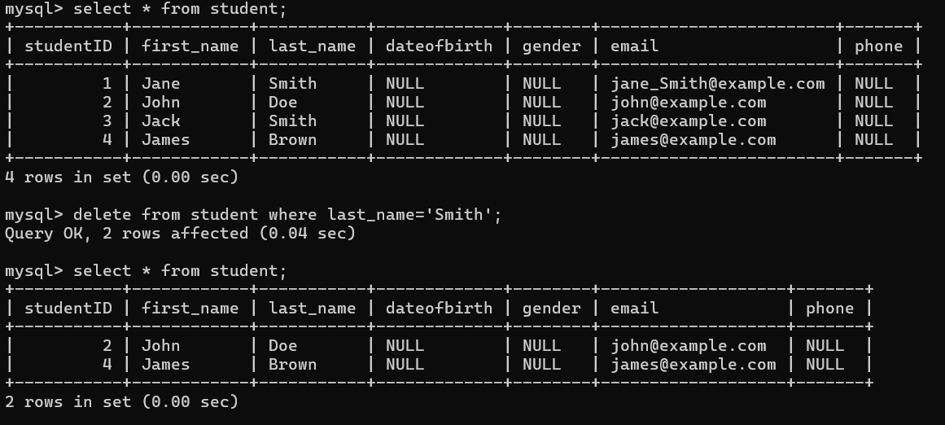

List the student whose first name starts with J.
